**IAM Policy Assignment**

(Shreyas Umesh Bhinge)

**Problem Statement:**

You work for XYZ Corporation. To maintain the security of the AWS account and there sources you have been asked to implement a solution that can help easily recognize and monitor the different users.

Tasks To Be Performed:

1. Create policy number1 which lets the users to:

a. Access S3 completely

b. Only create EC2 instances

c. Full access to RDS

2. Create a policy number2 which allows the users to:

a. Access CloudWatch and billing completely

b. Can only list EC2 and S3 resources

3. Attach policy number1 to the Dev Team from task1

4. Attach policy number2 too Ops Team from task 1

1. **Create Policy number 1**

**a. Access S3 completely**

**b. Only create EC2 instances**

**c. Full access to RDS**

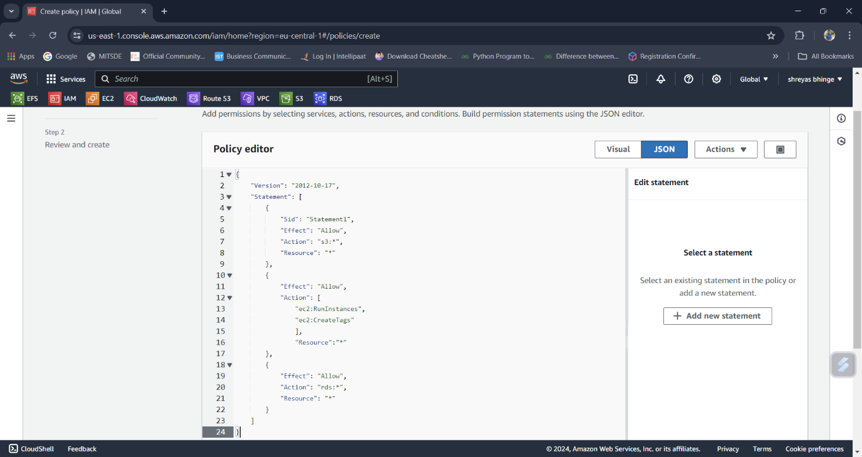

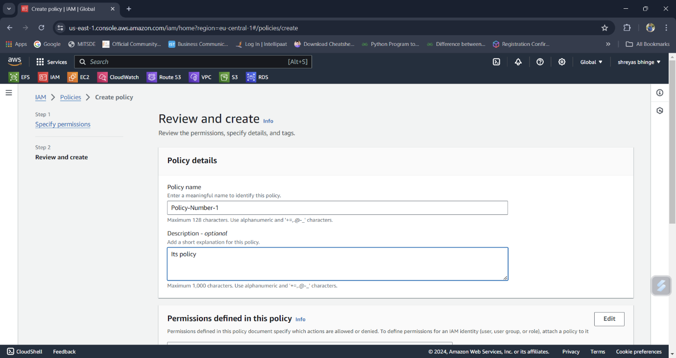

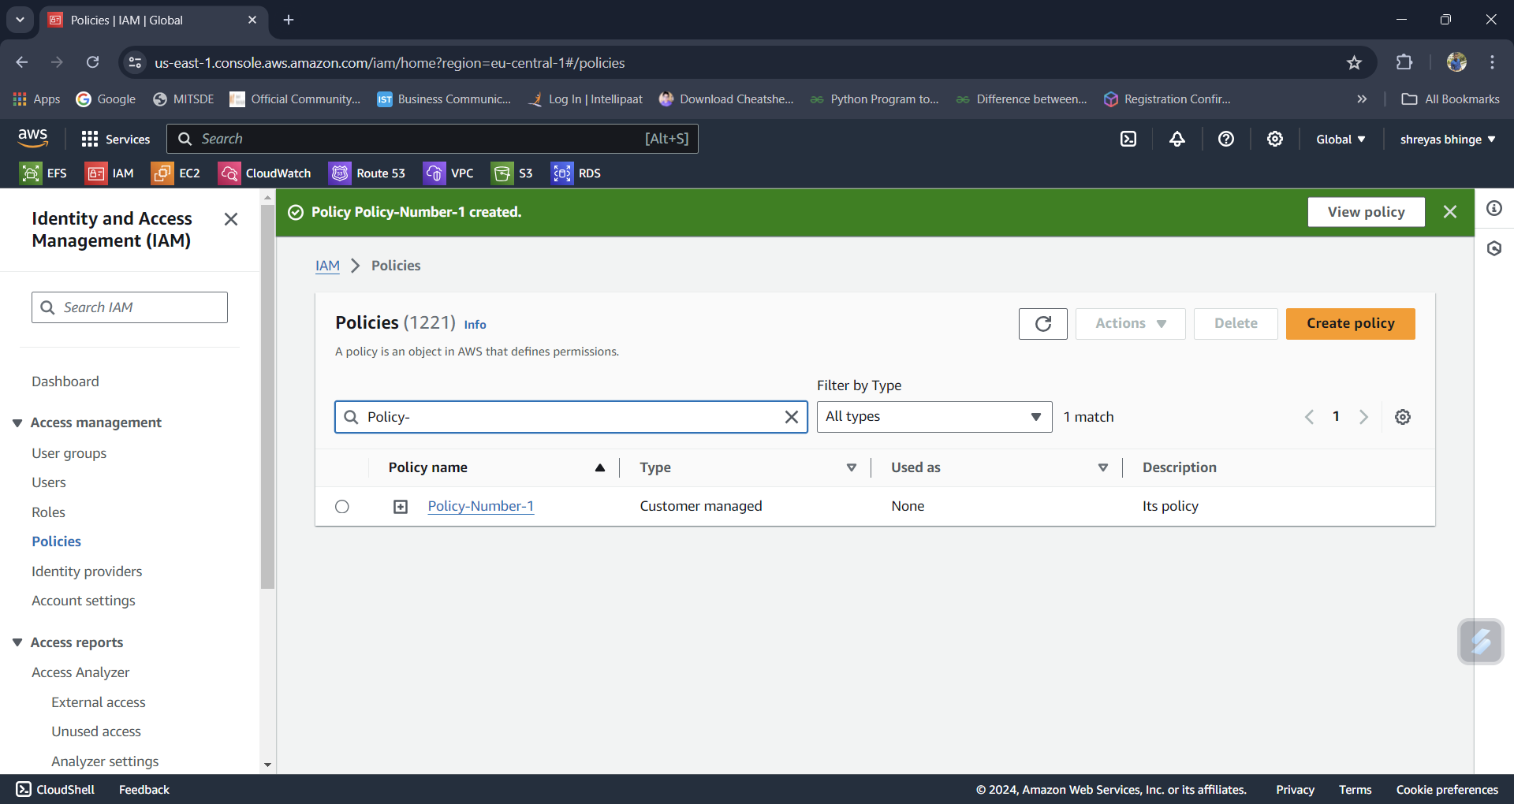

**2. Create a policy number2 which allows the users to:**

**a. Access CloudWatch and billing completely**

**b. Can only list EC2 and S3 resources**

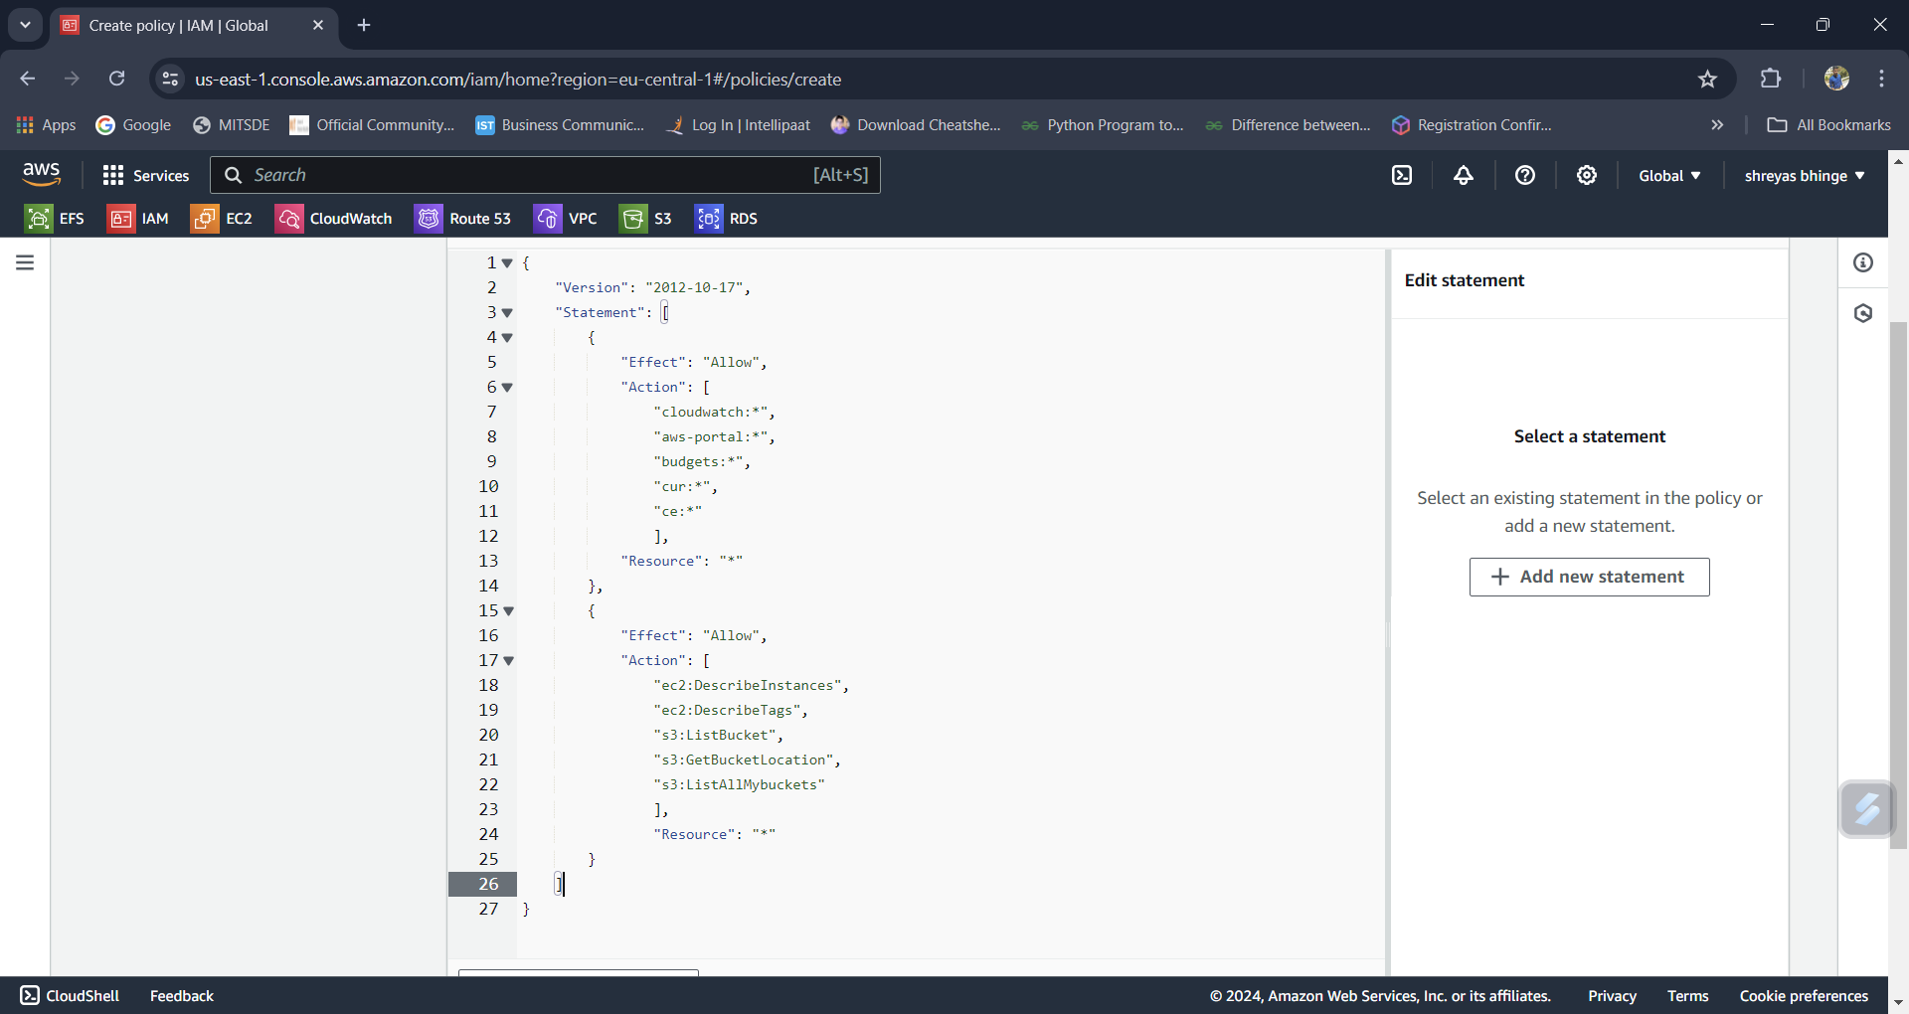

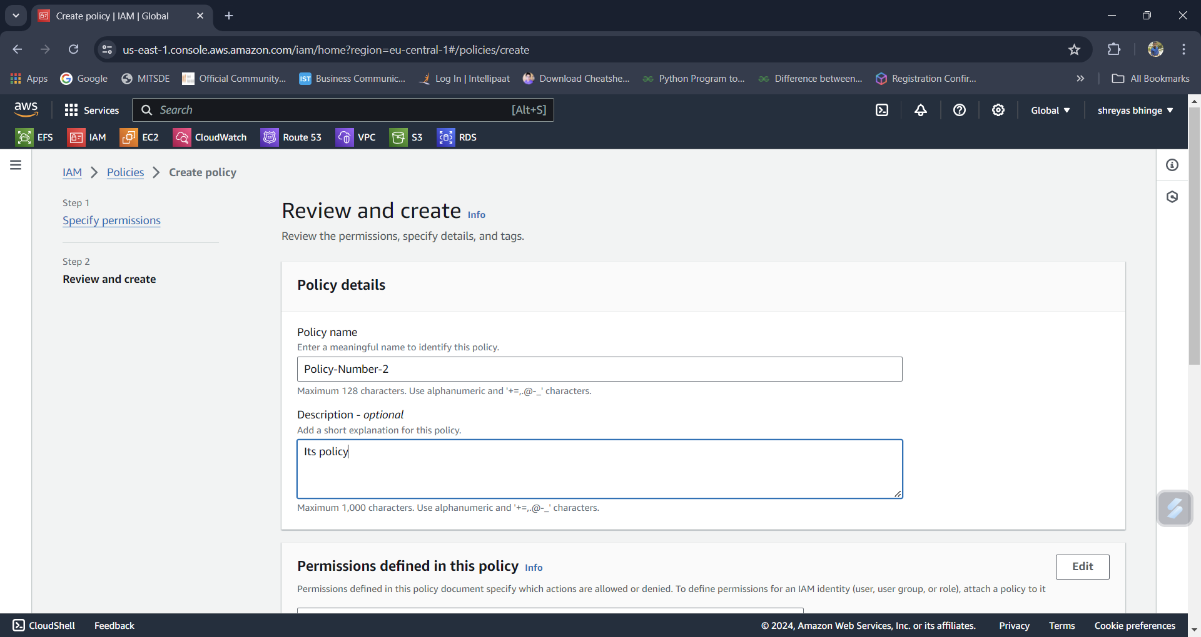

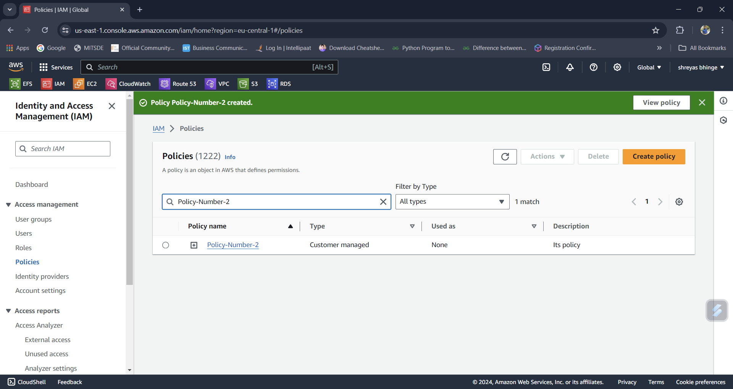

**3. Attach policy number1 to the Dev Team from task1**

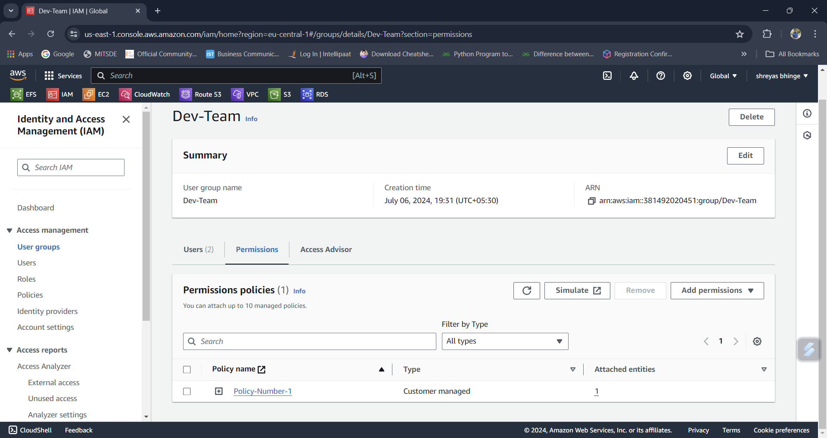

**4. Attach policy number2 too Ops Team from task 1**

